**Zomato Dashboard**

**Objective Questions**:

1. What is the total no. of tables present in the data?

Total Number of tables-8

1. What is the total no. of attributes present in the data?

**Total number of attributes are 28**

1. How many categorical columns are there in the data? [Search about categorical and continuous data, and try to answer this question]

**Categorical values-16**

**Continuous values-12**

1. The data consists of some inconsistent and missing values so ensure that the data used for further analysis is cleaned.

It is cleaned,missing values in cuisine column is imputed missing values with 0

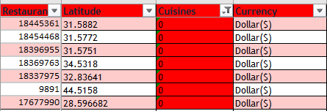

1. Using the LookUp functions, fill up the countries in the original data using the country code

Lookup function used on country

1. Create a table to represent the number of restaurants opened in each country.

* **APPROACH -** Created a pivot table using Raw Data, in row added the country and in value added the Restaurant Name and summaries by count function.
* **FINDINGS -** The total number of restaurants in the given data set is **9551.** India has the highest number of restaurants among all countries around **8652** restaurants and Canada has the least number of restaurants, that is **4**.
* **REFERENCE-OBJECTIVE PAGE IN** ZOMATO DAHBOARD EXCEL SHEET

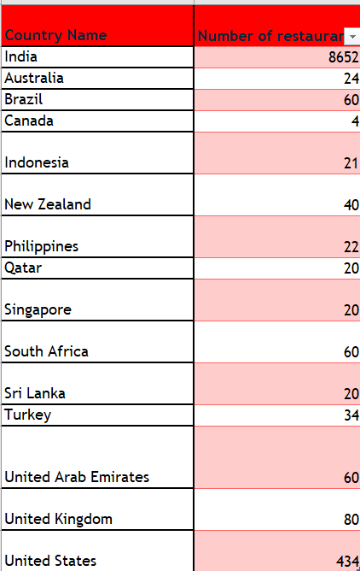

1. Also, the management wants to look at the number of restaurants opened each year, so provide them with something here.

* **APPROACH -** Created a pivot table using Raw Data, add Year in row and Restaurant Name in value and summaries by count function. Along with this, I’ve also created a Bar chart for the better representation of data on how many restaurants have opened in each year.
* **FINDINGS -** This data confirms that more than 1000 restaurants are opened each year.
* As per the analysis, the maximum number of restaurants open in **2018 (i.e. 1102)** and the minimum number of restaurants open in **2012 (i.e. 1022)**.

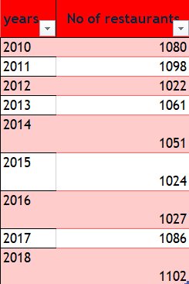

8.What is the total number of restaurants in India in the price range of 4?

* **APPROACH -** Created a pivot table using Raw Data, add country in row and Restaurant Name in value, apply filter on price range then select 4 and filter on country name then select India.

We can also derive The total number of restaurants in India using COUNTIFS Function **=COUNTIFS(Table3[Country],"India",Table3[Price_range],"=4")**

**388**

* **FINDINGS -** The total number of restaurants in India which are in the price range of 4 are **388**.

**=COUNTIFS(Table3[Country],"India",Table3[Price_range],"=4")**

**388**

9.What is the average number of voters for the restaurants in each country according to the data?

* **APPROACH -** Created the pivot table and add country in row and votes in value and summaries by Average function. Used stacked area chart for better visuals.
* **FINDINGS -** As per our data, Indonesia has the highest mean exactly **772** votes among all the countries and Brazil got minimum average of votes i.e. **19**. **REFERENCE-OBJECTIVE PAGE IN** ZOMATO DAHBOARD EXCEL SHEET 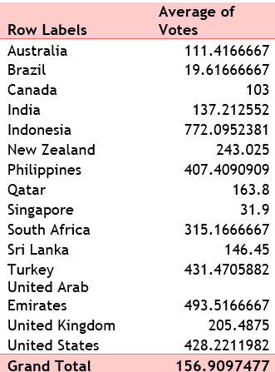

10.Calculate the average rating for all the restaurants that have price_range < 4 and provide online delivery. Use only the “IF” function, Logical Operators, and Aggregation functions to solve this problem. **[Note: Don’t use Conditional aggregation in this question.]**

* **REFERENCE-OBJECTIVE PAGE IN** ZOMATO DAHBOARD EXCEL SHEET

**=IF(COUNTIFS(Table3[Price_range],"<4",Table3[Has_Online_delivery],"Yes")=0,"No restaurants meet the conditions",AVERAGEIFS(Table3[Rating],Table3[Price_range],"<4",Table3[Has_Online_delivery],"Yes"))**

3.273812

1. Using Conditional formatting highlight the rows of restaurants that are located in the countries or cities that you’ve suggested to the management for opening new restaurants.

**Highlighted**

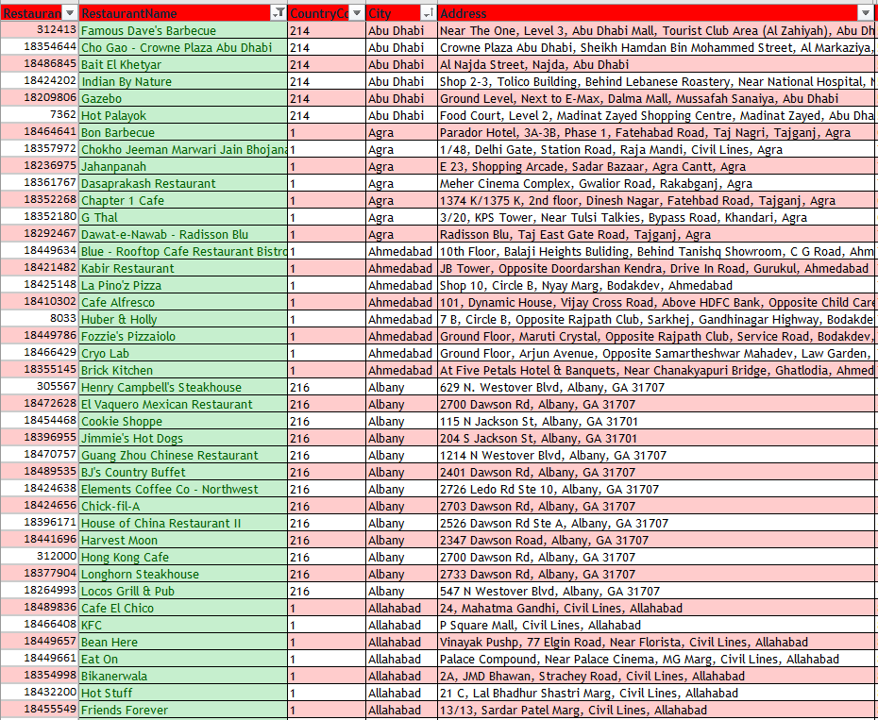

1. Create a new customized price column that consists of the abbreviation/symbol of the currency along with the Average_cost_for_two value. [Use string operations to do this task]

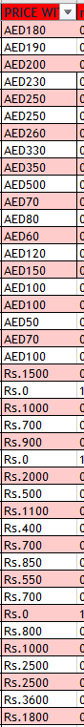

**Created**

1. How can you create an array formula in Excel or Google Sheets to count the number of restaurants listed that do not offer online delivery, are in the lowest price range, and have an average cost for two people less than or equal to 250 Indian Rupees?

**Refer objective page in excel sheet**

**=COUNTIFS(Table3[Has_Online_delivery], "No", Table3[Price_range], 1, table!Z2:Z9552, "<=250")**

**=1694**

**Subjective Question:**

1. Suggest a few countries where the team can open newer restaurants with lesser competition. Which visualization/technique will you use here to justify the suggestions?

**REFERENCE-SUBJECTIVE PAGE IN** ZOMATO DAHBOARD EXCEL SHEET

* **APPROACH -** In the Raw data, country is available hence created a pivot table with country in row and Restaurants name in value & summaries by count function. Rating name in value & summaries by Average function. Filtered Countries where the number of restaurants is less than 50.
* Firstly, filtered out the countries where the number of restaurants was less than 50. This will help us to understand where the competition is less.
* **INSIGHTS** - But we also have to look at the current market scenario. There can be fewer popular restaurants which are highly in demand. These Restaurants can give us a tough competition and make it difficult to grab the market. To avoid this, have added the average rating in the Pivot Table to understand the market scenario. After this, those countries were automatically filtered having less than 5 average ratings.
* Having less rating clearly states that the people from those countries were not very satisfied with the quality of the food of the restaurants around them. Those were the right place for our expansion and will take care of their local food, market needs and the quality of food. We will offer more services like online delivery and table booking to increase the customer’s ratings because customers enjoy additional ease & convenience in their dining experience.
* **FINDINGS -** Here are a few countries & cities for opening new restaurants. As per the Survey, top 5 selected countries are given below, which are Canada, Indonesia, Singapore, Sri Lanka and Quatar. Created a pivot chart describing the Count of Restaurants and average of ratings. Similarly created a Column Chart where plotted the Count of Restaurants for the countries which are selected for better visuals.

**Shortlisted countries based on average price and max votes**

1. Come up with the names of States and cities in the suggested countries suitable for opening restaurants.

**APPROACH -** Firstly, Listed down all the cities in the selected countries along with the number of Restaurants along with the average rating for the city. In that Pivot table, added the country column in row and restaurants name in value, summaries by count function.

**FINDINGS -** we have **six** cities - “**Consort, Bandung, Vineland station , chathan kent, yorton ”** where we open new restaurants.

1. According to the countries you suggested, what is the current quality regarding ratings for restaurants that are open there?

* **Approach:** Firstly, filtered out the countries where the number of restaurants was less than 50. This will help us to understand where the competition is less.
* **INSIGHTS** - But we also have to look at the current market scenario. There can be fewer popular restaurants which are highly in demand. These Restaurants can give us a tough competition and make it difficult to grab the market. To avoid this, have added the average rating in the Pivot Table to understand the market scenario. After this, those countries were automatically filtered having less than 5 average ratings.

1. Also, what is the current expenditure on food in the suggested countries, so we can keep our financial expenditure in control?

**APPROACH -** Created a Pivot Table added Country in Rows and Average of Average_Cost_for_two_ in Values and then filtered only the selected countries. Apart from this, Created the visualization with the column Chart where we can see what is the average cost for two in the restaurants in the selected countries.

Findings- the price and money value changes so the currency has been converted to dollar to know the exact difference.

|  |  |
| --- | --- |
| **country** | **INR** |
| Canada | Rs.1875 |
| Indonesia | Rs.750 |
| Qatar | Rs.3000 |
| Singapore | Rs.4500 |
| Sri Lanka | Rs.500 |

1. Come up with the names of restaurants from the recommended states that are our biggest competitors and also those that are rated in the lower brackets, i.e. 1-2 or 2-3.

* **APPROACH -** Created the pivot table and used a rating filter in both cases, more than 4.5 for Biggest Competitors & less than 3 for no competition. Also used filter on cities. For better visualization, used the column chart to display this data.
* **FINDINGS -** As per the given data,we have restaurants **rated (2-3) and price converted to dollars as we could see price compared to high rated retaurants is high and rating(2-3) seems low**
* **Here consort from Canada and elite Indian restaurant and queens cofe from srilanka and makansutra gluttons bay from Singapore**

|  |  |
| --- | --- |
| **restaurant** | **average of two in rupees** |
| **Consort Restaurant** | Rs.1875 |
| **Elite Indian Restaurant** | Rs.900 |
| **Makansutra Gluttons Bay** | Rs.2250 |
| **Queen's Cafe** | Rs.1000 |



1. Which cuisines should we focus on in the newer restaurants to get better feedback? Does the choice of cuisines affect the restaurant ratings?

* **APPROACH -** To determine Rating, we add cuisines in row, rate in value and summaries by Average function in the pivot table.
* Firstly, listed all the Cuisines which are getting served in the selected country along with the average of Rating through which the rating has been decided and arranged the data into ascending order of average of rating. With this dataset, we will get to know the cuisines which are rated by a large number of people.
* **INSIGHTS -** we must know the cuisine is currently in demand. Now, we have taken the cuisines where the rating are below 4 rating. If the rating of any cuisine is above 4 rating then we should avoid the cuisines as there is a high chance of tough competition.
* the choices of cuisines do affect the rating of the restaurant because if we provide the customer with the type of food which is generally bad in the country with the good quality then there are high chances that they will like the food and give the restaurant higher ratings. But if we serve food which is already highly rated, then the smallest of the mistakes will lead to a bad rating.
* **FINDINGS -** In our newer restaurants, we should focus majorly on Asian american food and Continental food. Plotted a line chart for better visuals.

|  |  |
| --- | --- |
| **Row Labels** | **Average of Rating2** |
| **American** | **3.1** |
| **American, Japanese, Singaporean** | **3.2** |
| **American, Mexican** | **3.2** |
| **Asian** | **3.3** |
| **Cafe, Spanish, Turkish, Greek** | **3.2** |
| **Chinese, Canadian** | **3** |
| **Chinese, Continental, Singaporean** | **3.4** |
| **Indian, Street Food** | **3.4** |
| **Italian, French, Bakery, Cafe** | **3.2** |
| **Malaysian, North Indian, Sri Lankan** | **3.5** |
| **Singaporean, Australian, German** | **3.1** |
| **Singaporean, Chinese, Seafood, Malay, Indian** | **3** |
| **South Indian** | **3.4** |
| **Western, Fusion, Fast Food** | **3.2** |
| **Grand Total** | **3.228571429** |

1. According to our current data, should we go for online delivery and table booking? Does that affect the customer’s ratings?

* **APPROACH -** In Pivot chart, table booking in row and added average of rating in values. same with online delivery and created pie charts for better visualization.
* **INSIGHTS - Yes**. As per the survey, we must opt for online delivery and table booking, It affects the customer’s ratings.
* Restaurants offering more services (online delivery and table booking)tend to have higher ratings because customers enjoy additional ease & convenience in their dining experience. Refer to the pie charts for better clarity.
* We can offer the current high rating Restaurants to tie up with us. We can approach them.

1. Should the team keep the rate of cuisines higher? Will that affect the feedback? According to our data are the rates of cuisines and ratings, correlated?

* **APPROACH -** Created Pivot chart, as cuisines in row, added average of rating and price range in value.
* **INSIGHTS -** According to our data, the rates of cuisines and ratings are not directly correlated. But the quality and ratings are directly related. To get a higher rating, We must keep the rate of cuisines in the middle range and keep high quality cuisines in our newer Restaurants.

|  |  |  |
| --- | --- | --- |
| **Row Labels** | **Sum of Price_range** | **Average of Rating2** |
| **Asian, Indonesian, Western** | **3** | **4.6** |
| **Burger** | **3** | **4.4** |
| **Cafe, Italian, Coffee and Tea, Western, Indonesian** | **3** | **4.6** |
| **Desserts, Bakery, Western** | **3** | **4.6** |
| **Indian** | **14** | **4.375** |
| **Japanese, Sushi, Ramen** | **3** | **4.4** |
| **Juices, Desserts** | **2** | **4.5** |
| **Seafood** | **4** | **4.9** |
| **Sunda, Indonesian** | **9** | **4.9** |
| **Sushi, Japanese** | **3** | **4.9** |
| **Grand Total** | **47** | **4.606666667** |

1. What is the distribution of the number of restaurants of different price ranges in all the countries?

**APPROACH -** Used a pivot table to fetch the different price range of restaurants of all the countries, add Price range in row and Restaurants id in value and summaries by Count function.

**FINDINGS -** As a result, we can see that there are less number of restaurants having higher price range.

REFER SUBJECTIVE 2 PAGE IN EXCEL SHEET

|  |  |  |
| --- | --- | --- |
| **Row Labels** | **Count of RestaurantID** | **Count of Country** |
| 1 | 4444 | 4444 |
| 2 | 3113 | 3113 |
| 3 | 1408 | 1408 |
| 4 | 586 | 586 |
| **Grand Total** | **9551** | **9551** |

1. Explain your approach in brief for suggesting countries/cities in order to open new restaurants, if the objective and subjective questions would have been given to assist you. **[you have to give bullet pointers in order to answer this question]**

* Three main findings emphasize on the following:

1. Higher the number of services/cuisines provided by a restaurant, more likely it is to receive higher ratings.
2. Variety & quality of cuisines attracts the customers.
3. Higher Cost-for-2 for a Restaurant, the less likely it is to be popular.

**Conclusion**

1. Top 5 selected countries for our expansion are Indonesia, Qatar, Canada, Singapore, Sri Lanka.
2. Most suitable 6 cities for opening our new Restaurants are as follows - “**Consort, Bandung, Vineland station , chathan kent, yorton** . Our Major Focus will be on Canada, As this Country has 3 most suitable cities.
3. In our newer restaurants, we should focus majorly on American food, Indian food and Continental food. The Choice and variety of Cuisines affects the restaurantratings.
4. To get a higher rating, We must keep the rate of cuisines in the middle range and keep high quality cuisines in our newer Restaurants.
5. We must offer more services like online delivery and table booking to increase the customer’s ratings because customers enjoy additional ease & convenience in their dining experience.